Configuring TestNG using IntelliJ + Gradle

1. “No task available” problem

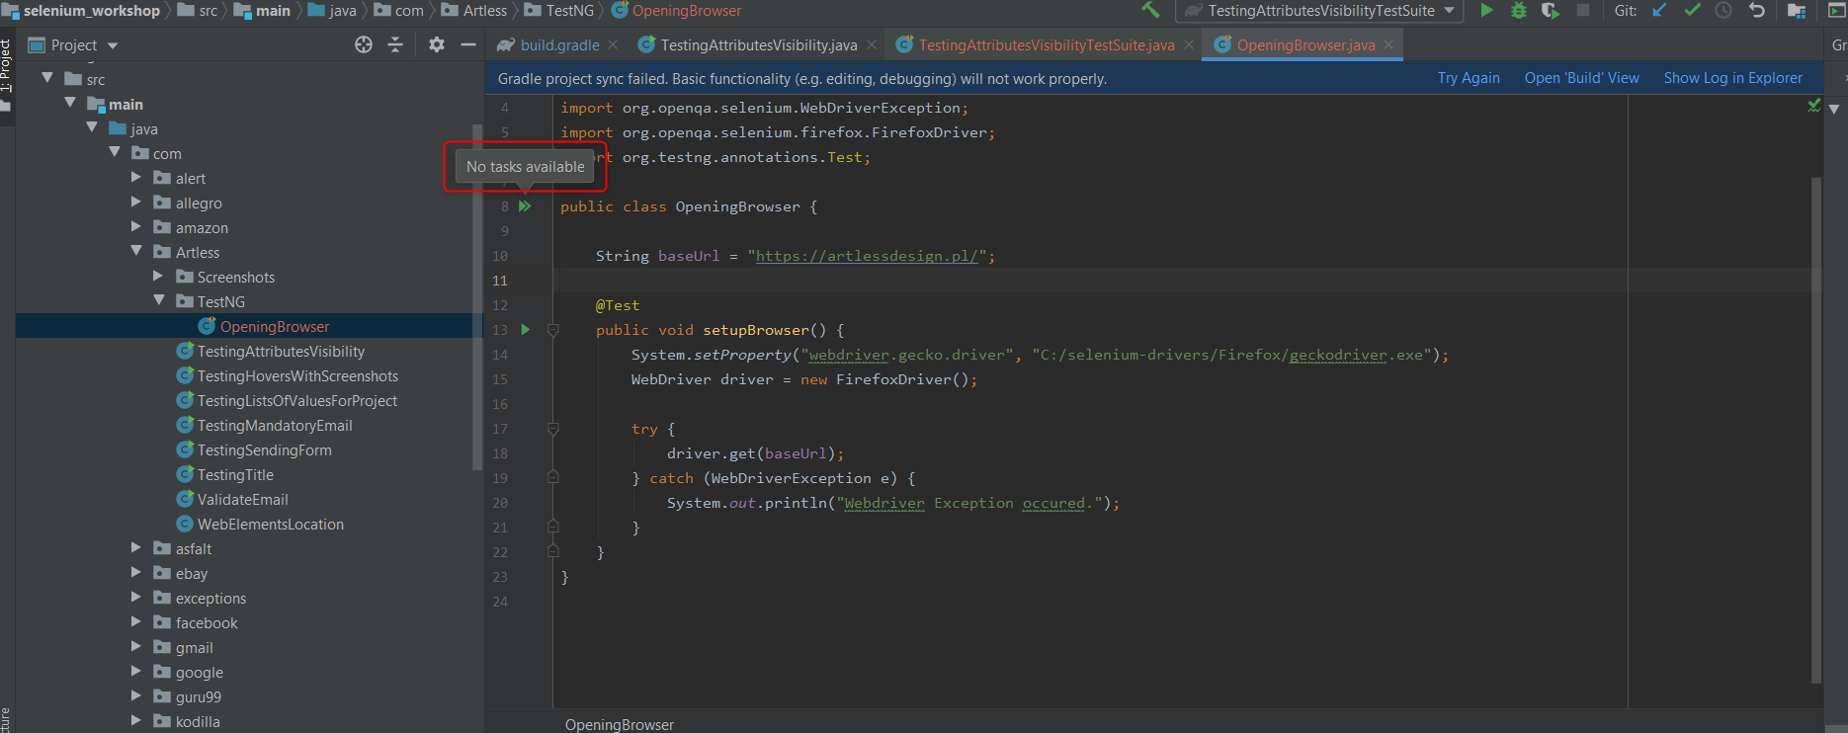

**Solution:**

Moving all Testing from “main” to “test”

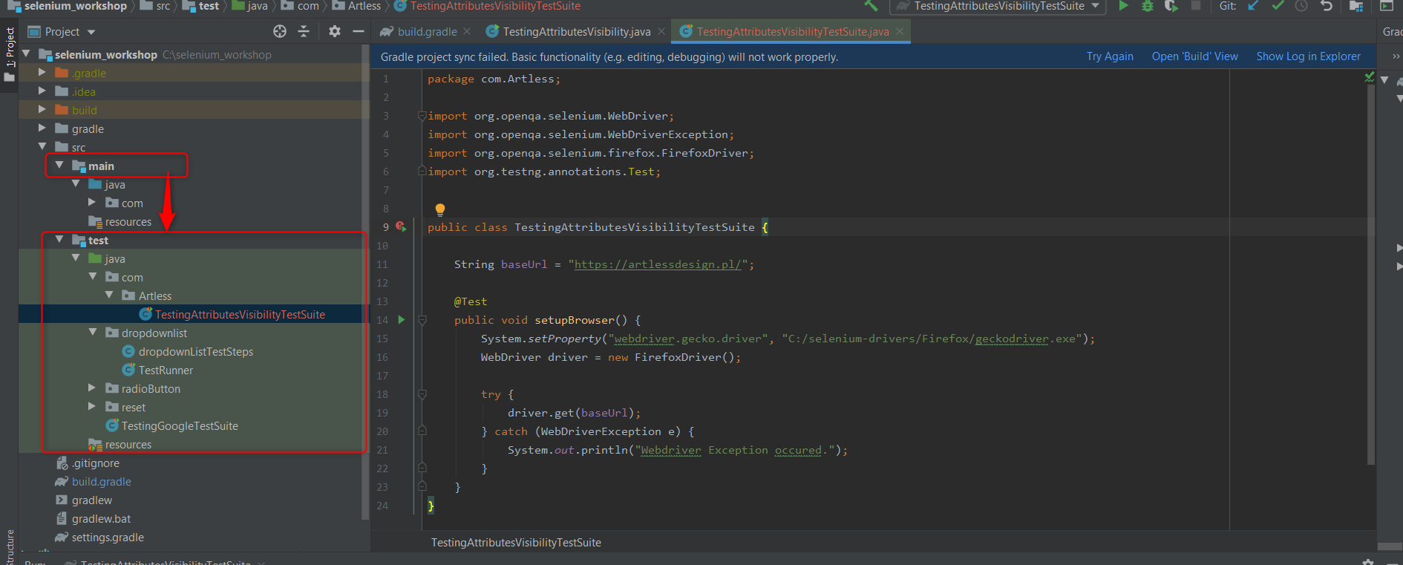

1. “No tests found” problem

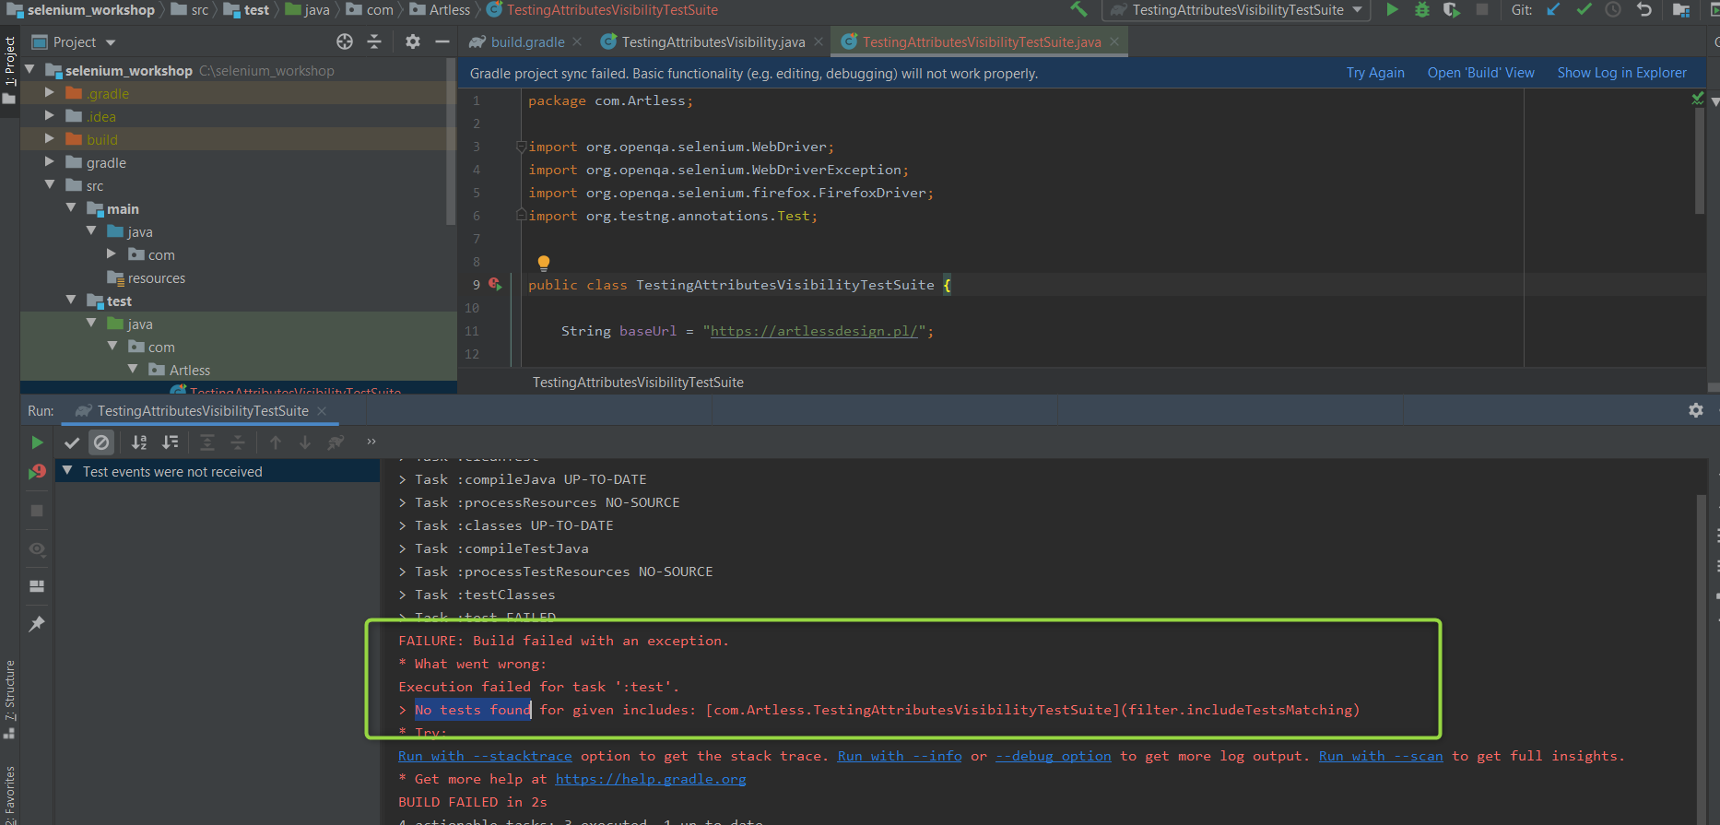

**Solution:**

Adding to gradlew.build:

test **{** useTestNG()  
**}**

or in case using Junit5

test **{** useJUnitPlatform()  
**}**

+ refreshing gradlew:

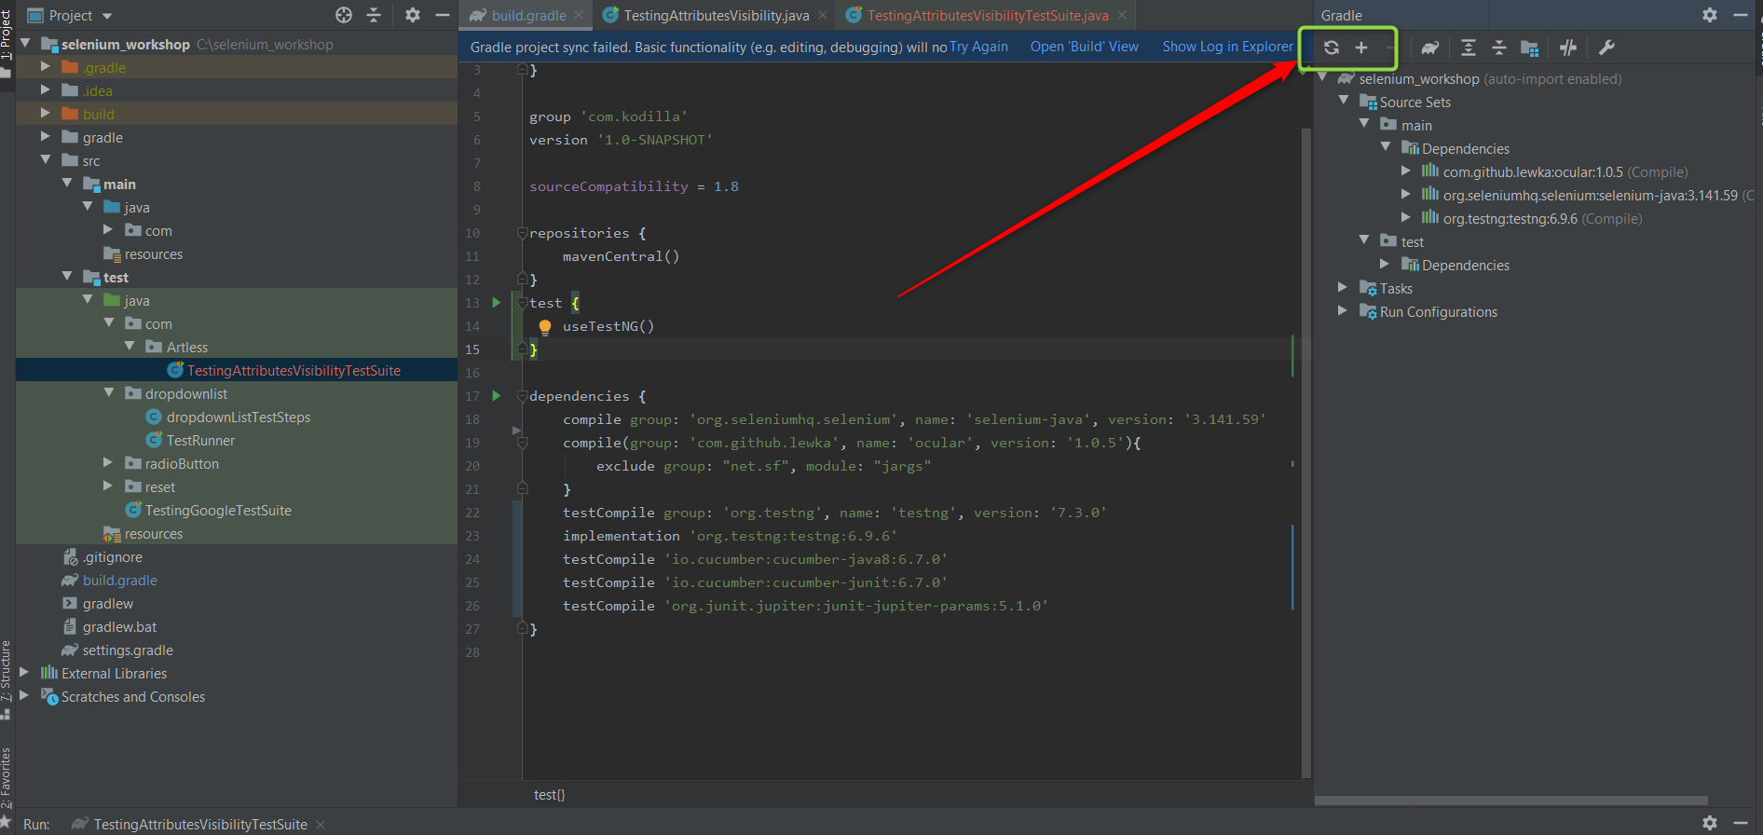

1. “java.lang.NoSuchMethodError” problem

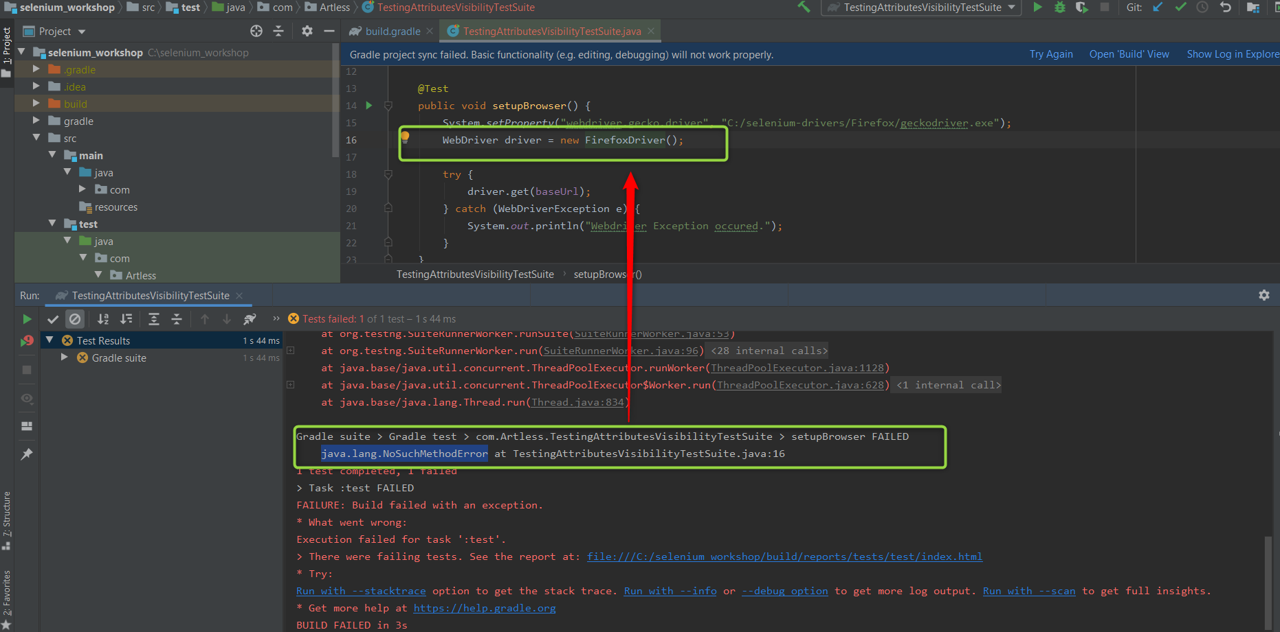

The problem was caused by:

com.google.common.collect.ImmutableSortedSet.toImmutableSortedSet(Ljava/util/Comparator;)Ljava/util/stream/Collector;

**Solution:**

Adding do gradlew.build to dependencies actual guava lib

compile group: 'com.google.guava', name: 'guava', version: '29.0-jre'